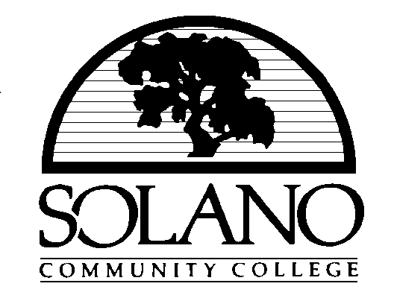

AGENDA

PLEASE NOTE: CHANGE IN LOCATION OF BOARD MEETING

The October 20, 2004, Board meeting of the Solano County Community College District Governing Board will be held in the Council Chambers, City of Vacaville, 650 Merchant Street, Vacaville, California 95688. If you have any questions or need further directions, please contact the President’s Office, Solano Community College, at 707 864-7112.

SOLANO COUNTY COMMUNITY COLLEGE DISTRICT

GOVERNING BOARD

Notice of Regular Meeting
October 20, 2004
7:00 p.m.

Council Chambers, City of Vacaville

650 Merchant Street
Vacaville, CA 95688

Please Note: Members of the public may address the Board on any item within the Board’s jurisdiction. Cards which must be completed requesting to address the Board are available at the press table and must be submitted to the Board Secretary at the meeting. Persons addressing items included on the agenda will be heard at the time the item is considered. Persons requesting to address items or subjects that are not on the agenda will be heard under the agenda item, “Comments from Members of the Public.” The Board cannot take action on any items not on the agenda unless authorized by law. Matters brought before the Board that are not on the agenda may, at the Board’s discretion, be referred to staff or placed on a future agenda.

1. CALL TO ORDER

2. PLEDGE OF ALLEGIANCE TO THE FLAG OF THE UNITED STATES OF AMERICA

3. ROLL CALL

James M. Claffey, President
Denis Honeychurch, Vice President
Pam Keith
Phil McCaffrey
Willie McKnight
Jerry R. Wilkerson
Vacancy from Area #4 – Benicia, Vallejo, Suisun
Lisa LaFarga, Student Trustee
Paulette J. Perfumo, Ph.D., Secretary

Commitment to our communities!

4. APPROVAL OF AGENDA

5. COMMENTS FROM MEMBERS OF THE PUBLIC

6. REPORTS (NO ACTION REQUIRED):

(a) Associated Students of Solano College (ASSC)

(b) Academic Senate

(c) Shared Governance Council

(d) Superintendent

- Bond Update

7. CONSENT AGENDA – ACTION ITEMS

All matters listed under the Consent Agenda are considered by the Board to be routine and will be enacted by the Board in one motion. There will be no discussion on these items prior to the time the Board votes on the motion unless members of the Board, staff or the public request specific items to be discussed and/or removed from the Consent Agenda. Time will be provided before the vote for clarification questions on any item under the Consent Agenda. Clarification questions may be asked without removing an item from the Consent Agenda.

Superintendent-President

(a) Minutes for the Meeting of October 6, 2004

(b) Donation, Page 1

Human Resources

(c) Employment – 2004-05; Gratuitous Service, Page 2

Administrative and Business Services

(d) Warrant Listings, Page 4

8. ITEMS REMOVED FROM CONSENT AGENDA

9. RETIREMENTS OF STAFF WITH 10 OR MORE YEARS OF SERVICE

(a) Resignations to Retire – Marva Canada, Sarah Phelan, Joseph Rapisarda, and A. Marie Young, Page 5

10. NON-CONSENT AGENDA ITEMS – ACTION ITEMS

Administrative and Business Services

(a) Adoption of the Official District Budgets for FY 2004/05: General Fund, Capital Projects Fund, Bookstore Fund, Page 6

Academic Affairs

(b) Solano Community College Facility Agreement with Dixon Fire Department – Fire Technology Program, Page 12

11. INFORMATION ITEMS – NO ACTION REQUIRED

(a) Governing Board Self Evaluation, Page 22

(b) Highlights of Strategic Plan Accomplishments 2003-04, Page 23

(c) Small Business Development Center, Page 24

12. ANNOUNCEMENTS

13. ITEMS FROM THE BOARD

14. CLOSED SESSION

(a) Public Employee Performance Evaluation
(Superintendent-President)

15. RECONVENE REGULAR MEETING

16. REPORT OF ACTION TAKEN IN CLOSED SESSION

17. ADJOURNMENT

PJP:js:pc

BDAGENDA102004

